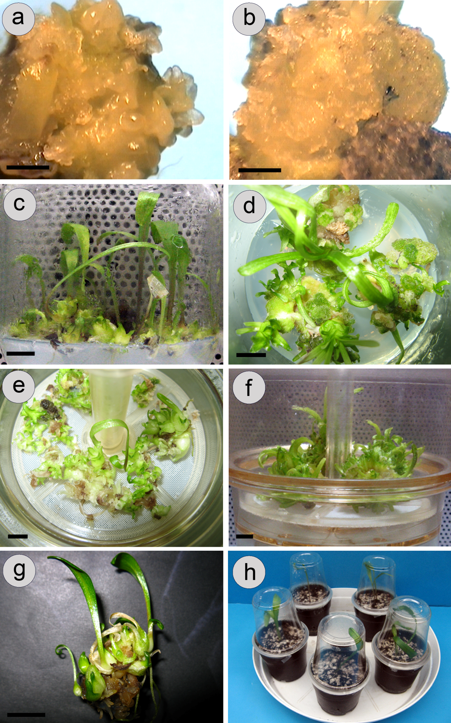

**Fig. 1.** Micropropagation of *Lilium ledebourii*. A) Induction of type I calli on solid MS medium containing 0.54 μM NAA and 0.44 μM BA in the darkness. B) Induction of type II calli on solid MS medium supplemented with 0.54 μM NAA and 0.45 μM TDZ in the darkness. C) Regenerated plantlets from type I calli on a solid hormone-free MS medium. D) Shoot organogenesis from type II calli on a solid MS medium free of hormones. E) Plantlets with shoots and roots from type I calli produced in a RITA® bioreactor. F) Shoot organogenesis from type II calli formed in a RITA® vessels. G) Plantlets were regenerated from type I calli with roots on the base of shoots. H) Plants in pots after 2 weeks of growth in a controlled environment. The Bars in A and B are represented 1 mm, whereas those in C, D, E, F and G are scaled in 1 cm.